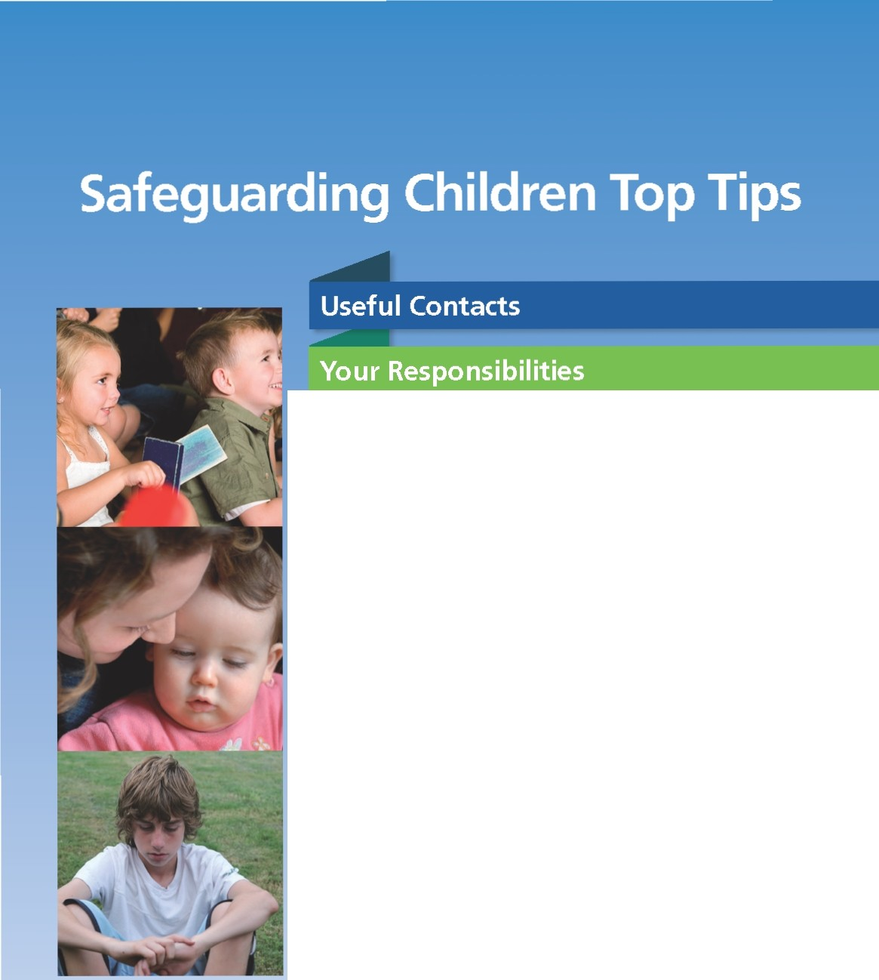
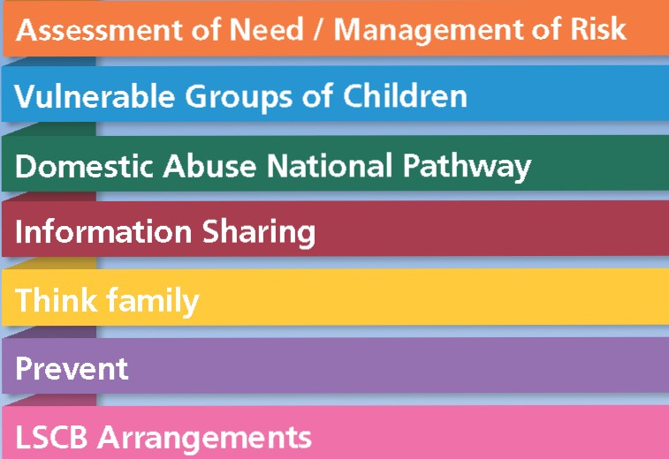

Categories and Indicators of Abuse

When to suspect child maltreatment

Early help

Resources & Further Reading

Telephone Numbers

Safeguarding Children Social Care Assessment Team East: 01226 438831
Safeguarding Children Social Care Assessment Team West: 01226 772423
Disabled Children’s Team: 01226 715517
Out of hours referrals to: Tel: 0844 9841800
Child Protection Enquiry: Tel: 01226 772400

South Yorkshire Police
Central Switchboard: Tel: 0114 2202020
Public Protection Unit: 0114 220 2020

NSPCC 24 Hour Helpline: Tel: 0808 800 5000
NSPCC Barnsley: 01226 779494

Childline 24 Hour Helpline: Tel: 0800 1111

Samaritans 24 Hour Helpline: Tel: 01709 361717
Local Samaritans 9am to 8pm: 01226 202222

National Women’s Aid: Tel: 0808 2000247

Pathways Domestic Violence Support Service:
Office: 01226 249800
Helpline: 01226 731812

Victim Support: 01226 243761
Judith House (Women and Children’s Refuge) 07721729591

Parentline Plus: Tel: 0808 800 2222

Barnsley Sexual Abuse and Rape Crisis Helpline: 01226 298566

Safeline Survivors of Sexual Abuse: Tel: 0808 800 5005

Youth Information and Support Services: 01226 299222

NHS Direct: Tel: 111

Safeguarding children

All staff within health services have a key role to play in safeguarding and promoting the welfare of unborn babies, children and young people. Children are defined as those under
the age of 18 years (Convention on the Rights of the child - 1989). Children have a “Right” (under the UN Convention
on the Rights of the Child - 1989) to have their best interests as the primary concern when decisions are made about them (Article 3).

They also have the right under the UN Convention to:

• Life and healthy development (Article 6)

• Be protected from hurt and mistreatment, physically or mentally (Article 19)

• Be properly cared for and protected from violence, abuse and neglect by their parents and anyone else who looks after them (Article 19)

• Be protected from activity which takes advantage of them and could harm their welfare and development, including sexual exploitation, sale and trafficking. (Article 36)

All staff who come into contact with children and their families have a responsibility to safeguard and promote their welfare and should know what to do if they have concerns about a child. This responsibility also applies to staff working primarily with adults who have dependent children that may be at risk because of their parent/carer health
or behaviours.
All health staff who come into contact with children and their families have a minimum responsibility to:

• Have the competences to recognise and understand what constitutes child maltreatment

• Recognise the potential impact of parent/carers physical and mental health on the well-being of the child

• Act as an effective advocate for the child.

• Be clear about own and other colleague’s roles and responsibilities and professional boundaries.

• Be aware of your Local Safeguarding
Children’s Board Policy and Procedures

• Know where to seek expert advice and support by knowing the contact details of your local/organisations Named and Designated Professionals

• Know when and how to make a referral to your local Children’s Social Care Service

• Know when and how to share Information about child welfare concerns

• Know how to record details of any concerns and any actions you take including reasons for no action

• You must be trained to the appropriate level in line with Safeguarding Children and Young People: Roles and Competences for Health Staff (Intercollegiate Document 2010)

Categories of abuse

Categories of Abuse (The following definition is taken from Working Together to Safeguard Children 2013.

Physical Abuse:

• Physical abuse may involve hitting, shaking, throwing, poisoning, burning or scalding, drowning, suffocating, or otherwise causing physical harm to a child or young person

• Physical harm may also be caused when a parent or carer fabricates the symptoms of, or deliberately induces illness in a child

Neglect:

The persistent failure to meet a child’s basic physical and/or psychological needs, likely to result in the serious impairment of the child’s health or development

Neglect can occur during pregnancy as a result of maternal substance misuse.

Once the child is born, neglect may involve a parent or carer failing to:

• Provide adequate food and clothing, shelter (including exclusion from home or abandonment)

• Protect a child from physical and emotional harm or danger

• Ensure adequate supervision (including the use of inadequate care-givers); or

• Ensure access to appropriate medical care or treatment

It may also include neglect of, or unresponsiveness to a child’s basic emotional needs.

Emotional Abuse

The persistent emotional maltreatment of a child such as to cause severe and persistent adverse effects on the child’s emotional development. It may involve conveying to a child that they are worthless or unloved, inadequate, or valued only insofar as they meet the needs of another person. It may include not giving the child opportunities to express their views, deliberately silencing them or ‘making fun’ of what they say or how they communicate. It may feature age or developmentally inappropriate expectations being imposed on children. These may include interactions that
are beyond a child’s developmental capability, as well as overprotection and limitation of exploration and learning, or preventing the child participating in normal social interaction. It may involve seeing or hearing the ill-treatment of another. It may involve serious bullying (including cyber bullying), causing children frequently to feel frightened
or in danger or the exploitation or corruption of children.

Sexual Abuse:

Sexual abuse involves forcing or enticing a child or young person to take part in sexual activities, not necessarily involving a high level of violence, whether or not the child is aware of what is happening.

It may involve:

• physical contact, including assault by penetration (rape or oral sex), or

• non-penetrative acts such as masturbation, kissing, rubbing and touching outside of clothing

• non-contact activities such as involving children looking at or in the production of sexual images

• watching sexual activities or

• encouraging children to behave in sexually inappropriate ways

or

• grooming a child in preparation for abuse (including via the internet)

Sexual abuse is not solely perpetrated by adult males. Women can also commit acts of sexual abuse, as can other children.

Cyber-bullying involves the use of information and communication technologies to support deliberate, repeated, and hostile behaviour by an individual or group that is intended to harm others.
New technologies have become central to modern life. They make it possible for people across the world to have instant communication with one another.
They allow for the rapid retrieval and collation of information from a wide range of sources and provide a powerful stimulus for creativity. People may
discuss sensitive topics which, face to face, they might find difficult. However, these technologies are also potentially damaging. They can enable children
and young people to access harmful
and inappropriate materials. Those they engage with may not be directly known to them and because of the anonymity offered by the internet children and young people may be harmed or exploited.

It is important to familiarise yourself with local E-safety processes:

• Policies, procedures and practices

• Education, training and information

Peer Abuse:

Peer Abuse can be defined as one who brings mistreatment, insult or deception in excessive amounts to another individual of the same peer group. This
is done physically, mentally, emotionally or sexually.

Vulnerable Parents:

Many families can suffer challenges
in bringing up their children in warm, loving and supportive environments. Parenting capacity can be compromised through parental mental illness, learning disability, substance misuse
and domestic violence. Sometimes practitioners may have limited or no contact with children. In these
circumstances practitioners need to maintain a Child-Focused Approach and keep a strong focus on the outcomes intended for children and young people, which is central to delivering a child focused approach.

Whistle Blowing:

If in doubt contact your nominated safeguarding children lead or
your Named/Designated Nurse for
Safeguarding

Managing Allegations:

Despite all efforts to recruit safely there will be occasions when allegations
of abuse against children are raised. The allegations may relate to the person’s behaviour at work, at home
or in another setting. All allegations of abuse of children by those who work with children must be taken seriously. Allegations against people who work with children, whether in a paid or unpaid capacity, cover a wide range
of circumstances.
If you are aware of a person who works with children and has:

• Behaved in a way that has harmed a child or may have harmed a child

• Possibly committed a criminal offence against or related to a child or

• Behaved towards a child in a way that indicates he/she is unsuitable to work with children

All such allegations made against adults working with children must be referred to the Local Authority Designated Officer (LADO) who provides advice and guidance to
employers and voluntary organisations, liaises with the police and other agencies and monitors the progress of cases
to ensure that they are dealt with as quickly as possible consistent with a thorough and fair process.

Local Safeguarding Children Boards (LSCBs) will have arrangements in place for monitoring and evaluating their effectiveness of the above.

If you consider or suspect child maltreatment it is good practice to follow the process outlined below – A Quick Reference Guide

Listen and observe...
Take into account the whole picture of the child or young person. Sources of information that help to do this include:

Seek an explanation...
for any injury or presentation from both the parent or carer and the
child or young person in an open and non-judgemental manner.
Record...
in the child or young person’s clinical re- cord exactly what is observed and heard from whom and when.
Record why this is of concern.

CONSIDER
child maltreatment... CONSIDER means maltreatment is one possible explanation
for the alerting feature or is included in the differential diagnosis.

At any stage during the process of considering maltreatment the level of concern may change and lead to exclude or suspect maltreatment.
SUSPECT
Child maltreatment... if an alerting feature or considering child
maltreatment prompts you to suspect child maltreatment refer the child or young person to children’s social
care, following Local Safeguarding Children Board procedures.
EXCLUDE
child maltreatment...
if a suitable explanation is found for the alerting feature. This may be the decision after discussion of the case with a more experienced colleague or gathering collateral information as part
of considering child maltreatment.

RECORD
all actions taken and the outcome.
Remember you are accountable for ensuring that appropriate help is provided to the child following any referral.

Ref: Nice Guidance 2008

Preventing of harm to children and young people is the purpose of child protection work. To determine if children or young people are at risk or likely risk of harm requires the systematic collection of information to inform a balanced risk assessment
in regard to the needs of children and young people.

Sound risk assessment assists practitioners to explore more explicitly with children and families what needs to change, especially in regard to the safety and welfare of a child. In the identification of both ‘need’ and ‘risk’
staff should build upon family strengths whilst keeping the needs of the
child central.

The Common Assessment Framework (CAF) offers a basis for early identification of children’s additional needs, the sharing of information between agencies and the coordination of service provision.

The Framework for the Assessment
of Children in Need and their Families (2000) provides a systematic basis for collecting and analysing information to support professional judgements about how to support children and families in the best interests of the child.

The above will then inform a balanced risk assessment in regard to what is known as regards to determining the presence of safety or danger in a family and thus informing a plan
of intervention.
Children Act 1989 - Section 17 (10):

A child shall be taken to be in need if:

• He is unlikely to achieve or maintain, or have the opportunity of achieving or maintaining, a reasonable standard of health or development without the provision for him of services by the local authority under this part

• His health or development is likely to be significantly impaired or further impaired, without the provision of such services

• He is disabled

Children Act 1989 - Section 47:

The Children Act 1989 introduces the concept of significant harm as the threshold that justifies compulsory intervention in family life in the best interests of children.

The local authority is under a duty to make enquiries to decide whether they should take action to safeguard or promote the welfare of a child who is at risk of significant harm.

AAssseessssmmeent off Neeeedd/MMaanagemeennttooffRRisiksk

Assessment Framework Triangle

health •

C
safeg
& pro we

hil
uard moti lfaree

family & environm
education •
emotional •
& behavioural

development •
identity •
• basic care
• ensuring safety

ing ng

d
• emotional warmth
• stimulation
• guidance &
boundaries

family & social •

afeg

rdi g
• stability

relationships •
social •
presentation
& p o
f
ti g

selfcare skills •
fa ily & environmental factors

Looked After Children

Children looked after are by definition children that are cared for by the
local authority. The term ‘looked after children and young people’ refers to children and young people who may be accommodated under a voluntary agreement with their parents or their own, under section 20 (2) (I) of the Children Act (1989) or an Emergency Protection Order under Section 44 of the Children Act (1989).

If new information is received about a child who is looked after where there are concerns or he/she is likely to be suffering from significant harm, a decision should be made in consultation
with children’s social care about whether a strategy discussion is held.

Children with Disabilities

The available UK evidence suggests that disabled children are at increased risk of abuse, and that the presence of multiple disabilities appears to increase the risk
of both abuse and neglect. Disabled children may be especially vulnerable to abuse for a number of reasons:

• Increased risk of being socially isolated with fewer outside contacts than non- disabled children

• Their dependency on parents and carers for practical assistance in daily living, including intimate personal
care, increases their risk of exposure to abusive behaviour

• They have an impaired capacity to resist or avoid abuse

Safeguards for disabled children are essentially the same as for non-disabled children.

Children who go missing from
Home/Care

The terms ‘young runaway’ and ‘missing’ in this context refer to children and young people up to the age of 18 years who have run away from their home
or care placement, have been forced to leave or whose whereabouts are unknown.

Children who decide to run away are unhappy, vulnerable and in danger. As well as short-term risks to their immediate safety, there are longer
term implications as well with children and young people who run away being less likely to fulfil their potential and live happy, healthy and economically productive lives as adults.

Children at risk of Sexual Exploitation

Children and young people who are sexually exploited are the victims of child sexual abuse and their needs require careful assessment. This group may include children who have been sexually abused through the misuse of technology, coerced into sexual activity by criminal gangs or the victim of trafficking.

The strong links that have been identified between different forms of sexual exploitation, running away from home, gang activity, child trafficking
and substance misuse should be borne in mind in the development of procedures.

Unaccompanied Asylum Seeking
Children (UASC)

These are “children who are under 18 years of age who have been separated from their parents and who are not being cared for by an adult who by
law or custom has the responsibility to do so” (UNHCR, 1994). In June 2003 guidance was issued that stated where children seeking asylum are alone the
‘presumption should be that they fall into Section 20 of the Children Act’ (DH, 2003).

Where there are safeguarding concerns relating to the care and welfare of any UASC then these must be investigated in line with LSCB procedures in the area in which they are living, in the same way as any looked after child.

Disclosure of Abuse
or Potential Indicators of Abuse

Ask the Question
Document when you ask the domestic abuse question and the response

Disclosure of Domestic Abuse and/or sexual violence
Explain the limits to confidentiality of the disclosure and what actions you may have to take

Consider and act if there are safeguarding adult issues
Are there any children? Consider concerns about a child’s safety, including unborn baby

Information Sharing
Follow your organisation and
LSCB guidelines

Discuss with Child Protection
Advisor/manager/colleague

Inform parent/carer of the need to refer to social care
(if appropriate and safe) Consider MARAC referral

Give information safely
Women’s Aid
National 24 hour helpline:
0808 2000 247
Local Helpline Number:
999 in emergency Local Domestic Abuse Explore options
Best Practice
Always talk to the woman alone
• Never pressure a woman to leave partner
• Discuss and ensure a safety plan is in place
• Reinforce options
• Explain the role of expert agencies
• Always use a professional interpreter. Never use family members or a client’s friend if English is not his/her first language.
• Always ensure complex Domestic Abuse cases are brought to supervision for discussion
• Document all contacts, when asking ‘the question’, disclosures, actions, observations etc

It is important that people remain confident that their personal information is kept safe and secure and that practitioners maintain the privacy rights of the individual, whilst sharing information to deliver better services.

You must use your professional judgement to decide whether to share information or not and what information is appropriate to share.

There are seven golden rules for information sharing:

1. Remember that the Data Protection Act 1998 is not a barrier to sharing information

2. Be open and honest with the person (and/or their family where appropriate) at the outset about why, what, how and with whom information will or could be shared and seek their agreement unless
it is unsafe or inappropriate to do so.

3. Seek advice if you are in any doubt without disclosing the identity of the person where possible

4. Share with consent where appropriate and, where possible, respect the wishes of those who do not consent
to share confidential information. You may still share information without consent if, in your judgement, that lack of consent can be overridden in public interest. You will need to
base your judgement on the facts of the case
5. Consider safety and well being of the person and others who may be affected by their actions

6. Necessary, proportionate, relevant, accurate, timely and secure

7. Keep a record of your decision and the reasons for it. Record what you have shared, with whom and for what purpose

Gillick Competency/Fraser Guidelines

When working with young people practitioners should use Gillick Competencies/Fraser Guidelines. These are in place to help assess whether a child has the maturity to make their own decisions and to understand the
implications of those decisions. The child must be capable of making a reasonable assessment of the advantages and disadvantages of the treatment proposed, so the consent, if given,
can be properly and fairly described as true consent.

Families have a range of needs and from time to time will require support or services to help meet them.

Difficulties that impact on one family member will inevitably have a knock-on effect on other family members. For this reason all practitioners should ‘Think Family’.

In a system that ‘thinks family’ both adults and children’s services should:

• Have no ‘wrong door’

• Look at the whole family

• Build on family strengths

• Provide support tailored to need
Individual practitioners working with either children or adults or both should:

• Ensure you know who has parental responsibility

• Who is living with the child/children

• Consider the involvement, potential contribution and (when appropriate) the risks associated with all the adults who have a significant influence on
a family, even if they are not living in the same house or are not formally a family member

• Have ready access to information to enable practitioners to consider impact of parents/carers condition, behaviour, family functioning and parenting capacity

• Identify and provide responsive services for families that are family focussed

Always prioritise the safety and welfare of children within a family.

The Government’s counter-terrorism strategy is known as CONTEST. Prevent is part of CONTEST and its aim is to
- stop people becoming terrorists or supporting terrorism.

CONTEST has four key principles:

• Pursue – stop terrorist attacks

• Prevent – to stop people becoming terrorists or supporting terrorism

• Prepare – where we cannot stop an attack, mitigate its impact

• Protect – strengthen overall protection against terrorism attack

The Health Service is a key partner in Prevent and encompasses all parts of the NHS, charitable organisations and private sector bodies which deliver health services to NHS patients.

Three national objectives have been identified for the Prevent strategy:

Objective 1: Respond to the ideological challenge of terrorism and the threat we face from those who promote it.

Objective 2: Prevent people from
being drawn into terrorism and ensure that they are given appropriate advice and support.

Objective 3: Work with sectors and institutions where there are risks of radicalisation which we need to address.
Prevent focusses on working with vulnerable individuals who may be at risk of being exploited by radicalisers and subsequently drawn into terrorism related activity. What is important, if you are concerned that a vulnerable individual is being exploited in this
way, you can raise these concerns in accordance with your organisation’s policies and procedures.

Contracts of employment and professional codes of conduct require all health care staff to exercise a duty
of care to patients and, where necessary, take action for safeguarding and
crime prevention.

If you have a concern, discuss it with your Safeguarding Lead and they will advise and identify local referral pathways.

The Local Safeguarding Children Board (LSCB) is the key statutory mechanism for agreeing how the relevant organisations in each local area will
co-operate to safeguard and promote the welfare of children and for ensuring the effectiveness of what they do.

The core functions of an LSCB are;

• Developing policies & procedures

• Communication & raising awareness

• Monitoring & evaluation

• Participation in planning &
commissioning

• Reviewing the deaths of all children in their area
• Undertaking Serious Case Reviews (SCRs) Child Death Overview Panel (CDOP):-
Each death of a child is a tragedy for his or her family (including any siblings), and subsequent enquiries/investigations should keep an appropriate balance between forensic and medical requirements and the family’s need
for support. There are 2 interrelated processes for reviewing child deaths (either of which can trigger a Serious Case Review (SCR).

1. Rapid response by a group of key professionals who come together for the purpose of enquiring into and evaluating each unexpected death of a child.
2. An overview of all child deaths up to the age of 18 years (excluding both those babies who are still born and planned terminations of pregnancy carried out within the law) in the LSCB area, undertaken by a panel.

Serious Case Reviews (SCR):

A serious case is one where: abuse or neglect of a child is known or suspected; and either — the child has died; the
child has been seriously harmed and there is cause for concern as to the
way in which the authority, their Board partners or other relevant persons have worked together to safeguard the child.

In addition, an SCR should be carried out when a child dies in custody, in police custody, on remand or following sentencing, in a Young Offender Institution, in a secure training centre or a secure childrens’ home or where the child was detained under the Mental Health Act 2005.

From 2013 there will be a national panel of independent experts to advise LSCBs about SCRs.

The role of the panel will be to support LSCBs in ensuring that appropriate action is taken to learn from serious
incidents in all cases where the statutory
SCR criteria are met and to ensure that those lessons are shared through publication of final SCR reports.

The panel will also report to the Government their views of how the SCR system is working.

The panel’s remit will include advising
LSCBs about:

• application of the SCR criteria;

• appointment of reviewers; and

• publication of SCR reports. Parallel Processes Serious Incidents (SIs):
Serious incidents in health care are uncommon but when they occur the NHS has a responsibility to ensure there are systematic measures in place for safeguarding people, property, NHS resources and reputation. A national framework for reporting and the management of serious incidents for investigations (previously known
as Serious Untoward Incidents/SUIs) occurring in the NHS and those parts of the independent sector that provides NHS services in England.
Domestic Homicide Reviews (DHR):

A ‘Domestic Homicide Review’ is a review of circumstances in which the death of a person aged 16 years or over has or appears to have resulted from violence, abuse or neglect by:

• A person to whom he/she was related or with whom he/she was or had been in an intimate personal relationship or

• A member of the same household as themselves

The purpose of DHR:

• Establish what lessons are to be learned from the DHR

• Apply these lessons to service
responses including changes to policies and procedures as appropriate

• Prevent domestic violent homicide and improve service responses

• Not to apportion ‘blame’ to organisations/agencies

What you need to know:

Sometimes deprivation of liberty (DoL) is required to provide care/treatment and protect people from harm BUT every effort should be made to prevent DoL
by making provision to avoid placing restrictions. If DoL cannot be avoided it should be for no longer than is necessary.

There is a legal duty on the hospital or care home, if the Safeguards apply, to request the CCG or local authority to authorise to deprive someone of their liberty for a limited period of time.

A major part of preventing DoL is minimising any restraint. Restraint must be appropriate, proportionate and in the patient’s best interests.

What to do:

If you are worried about a patient in your care who you think might be being deprived of their liberty, consider ways in which you can minimise restrictions. Please refer to your local DoLS procedures.

Discuss the case with your Adult
Safeguarding Lead.

In a community setting you can contact your Local Authority DoLS team who will be able to assist.

It is important to act quickly to comply with legislation.

Health Visitors, School Nurses, Midwives and GPs are a key part of ensuring children, young people and families get extra help and support when they need it.

They will offer ‘early help’ through providing care and/or by referral or signposting to other services. Early help can prevent problems developing or worsening.

‘The Health Visitor Implementation Plan 2011-15’ and ‘Getting it right for Children, Young People and Families’, set out an ambitious plan that will implement a new framework, promote innovation and disseminate the good practice that exists in many services across the country.

This service is based on the four elements shown below.

1
They will ensure that children and young people everywhere receive high quality services which improve health and
reduce health inequalities. They detail the service that families and young people can expect from their Health Visiting and School Nursing service.

Your Community

2 Universal
Safeguarding

3 Universal Plus

Universal Partnership Plus
4

• Working Together to Safeguard Children: A guide to interagency working to safeguard and promote the welfare of children (2013)

• Children Act 1989 (2004)

• Information sharing: Guidance for practitioners and managers (2008)

• Framework for Assessment of Children in Need (2000)

• If you consider or suspect child maltreatment (NICE Guidance 2008)

• Building Partnerships, Staying safe – The health sector contribution to HM Governments Prevent strategy (2011)

• Statutory guidance on making arrangements to safeguard and promote the welfare of children under section 11 of the Children
Act 2004

• Child Care Act 2006

• The Munro Reviews of Child Protection
2011/2012

• Safeguarding Children and Young People: Roles and Competence for Health Care Staff (Intercollegiate document 2010)
• UN Convention on the Rights of the
Child (1989)

• Health Visitor Implementation Plan
(2011)

• Getting it Right for Children, Young people and Families, maximising the contribution of the school nursing team: Vision and Call for Action (2012)

• Statutory Guidance on promoting the Health and Wellbeing of Looked After Children (2009)

This prompt card was inspired by NHS East Midlands.

